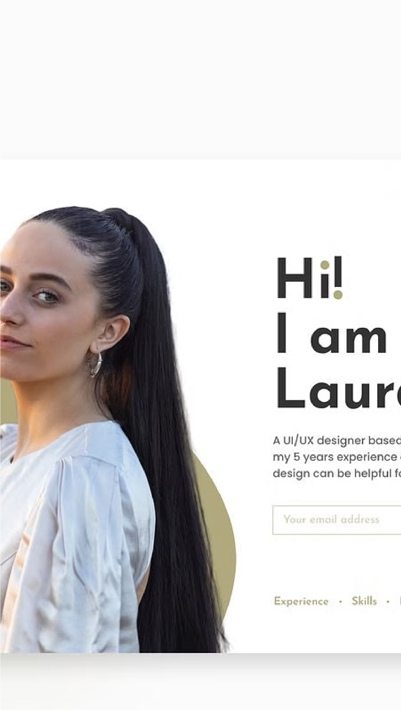

**Introduction to**

**Personal**

**Portfolio**

**Website**

Developing a personal portfolio website is an essential step for any

professional looking to showcase their skills, experience, and

accomplishments. This interactive and visually engaging platform

serves as a powerful tool to connect with potential employers, clients, or

collaborators, highlighting your unique talents and differentiating you

from the competition. By crafting a well-designed, informative, and

compelling personal portfolio, you can effectively communicate your

brand, showcase your best work, and leave a lasting impression on

your audience.

**HTML Structure and Semantic**

**Markup**

**Solid Foundation**

Establishing a strong HTML

structure is the foundation of

a well-built personal portfolio

website. By utilizing semantic

markup, you can create a

clear and organized hierarchy

of content, making it easier

for both users and search

engines to navigate and

understand the information

presented.

**Accessibility**

Incorporating semantic HTML

elements, such as header,

nav, main, and footer, not

only improves the overall

structure of your website but

also enhances accessibility

for users with disabilities,

ensuring your portfolio is

inclusive and user-friendly.

**Search Engine**

**Optimization**

Optimizing your HTML

markup with relevant

keywords, meta tags, and

structured data can

significantly boost your

website's visibility and

ranking in search engine

results, making it more likely

for potential employers or

clients to discover your

impressive portfolio.

**CSS Styling and Responsive**

**Design**

**Visual Appeal**

Crafting a visually stunning portfolio website

requires the strategic use of CSS to apply

custom styles, colors, typography, and

layout. By meticulously designing each

element, you can create a cohesive and

aesthetically pleasing user experience that

reflects your personal brand and design

sensibilities.

**Responsive Adaptation**

In today's mobile-first world, it's crucial to

ensure your portfolio website is responsive

and optimized for a variety of devices and

screen sizes. CSS media queries and

flexible grid systems allow you to create a

seamless experience for your audience,

regardless of the device they're using to

access your portfolio.

**Consistent Branding**

Consistent branding across your portfolio

website, from color schemes to typography,

helps establish a strong and memorable

visual identity. This cohesive approach not

only enhances the overall aesthetic but also

reinforces your personal brand and makes a

lasting impression on your audience.

**Accessibility**

Incorporating accessibility best practices,

such as proper contrast ratios, alt text for

images, and keyboard navigation, ensures

that your portfolio website is inclusive and

provides an enjoyable experience for all

users, regardless of their abilities or devices.

**Bootstrap Framework**

**Integration**

**Responsive**

**Design**

Bootstrap's built-in

responsive design

features, such as a

flexible grid system

and mobile-first

approach, make it

easier to create a

portfolio website that

adapts seamlessly to

various screen sizes

and devices.

**Prebuilt**

**Components**

Bootstrap provides a

wide range of pre-

designed UI

components, including

buttons, navbars,

forms, and more,

allowing you to quickly

and efficiently build a

professional-looking

portfolio website.

**Customizatio**

**n**

The modular nature of

Bootstrap makes it

easy to customize and

extend the framework

to align with your

unique design

preferences and

branding, ensuring

your portfolio stands

out from the crowd.

**Robust**

**Community**

With a large and

active community of

developers, Bootstrap

benefits from ongoing

support, regular

updates, and a wealth

of resources, making it

a reliable and future-

proof choice for your

portfolio website.

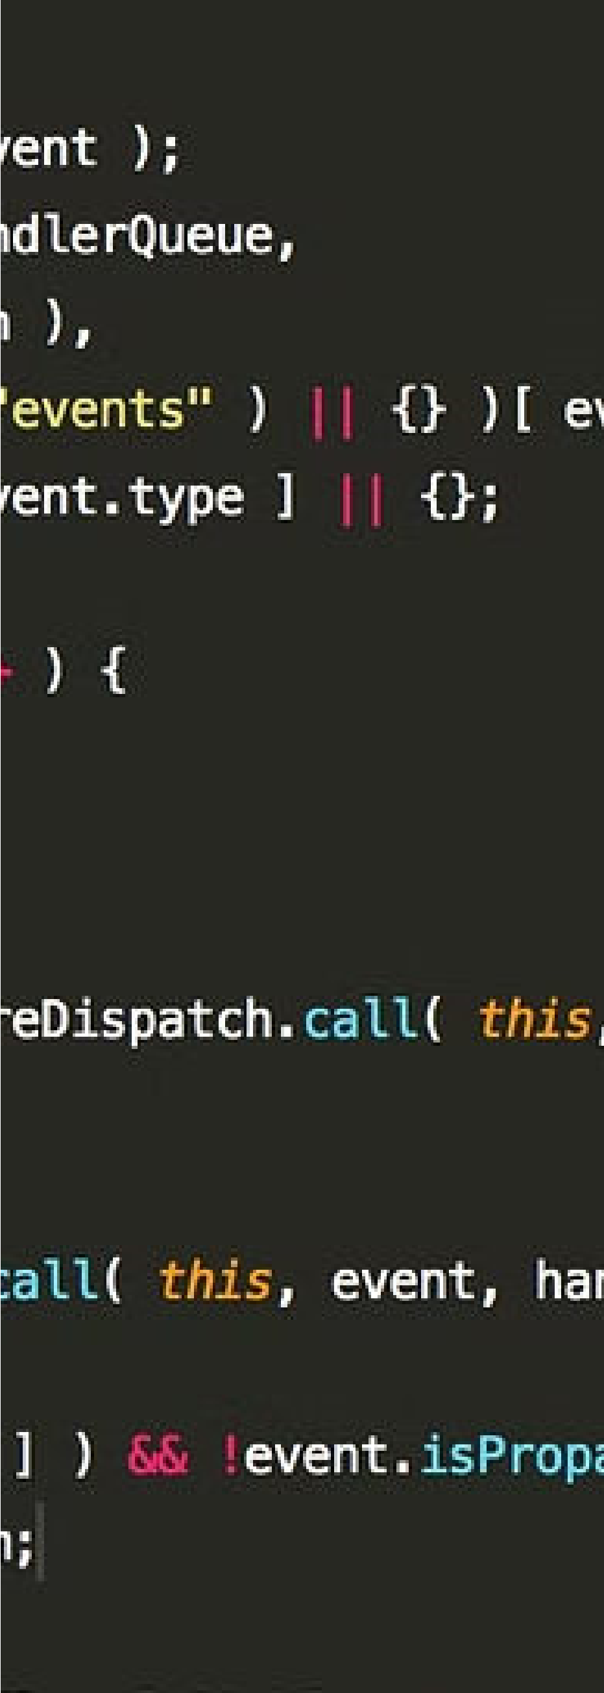

**JavaScript Functionality and**

**Interactivity**

**1**

**Dynamic Content**

Integrating JavaScript into your portfolio website allows you to create

dynamic content, such as interactive galleries, animated transitions, and

responsive forms, enhancing the overall user experience and showcasing

your technical skills.

**2**

**Smooth Navigation**

JavaScript-powered navigation, including smooth scrolling, dropdown

menus, and anchor links, can improve the user's journey through your

portfolio, making it easier for them to access and explore your work.

**3**

**Personalized Interactions**

By leveraging JavaScript, you can incorporate personalized interactions,

such as form validations, hover effects, and custom animations, adding a

touch of personality and engagement to your portfolio website.

**Showcasing Projects and Work**

**Samples**

**1**

**Project Highlights**

Carefully select and feature your most

impressive and relevant projects,

showcasing the depth and breadth of

your skills and expertise. Provide clear

and concise descriptions that highlight the

challenges, solutions, and outcomes of

each project.

**2**

**Visual Presentation**

Accompany your project descriptions with

high-quality visuals, such as screenshots,

wireframes, or design mockups, to give

your audience a tangible understanding

of your work and the final deliverables.

**3**

**Client Testimonials**

Incorporate client or employer

testimonials to reinforce the value you've

provided and build trust with your

audience, demonstrating your ability to

deliver exceptional results and exceeding

expectations.

**4**

**Contextual Details**

Provide relevant contextual details about

each project, such as the technologies

used, the project's scope, and any unique

challenges or achievements, to give your

audience a comprehensive understanding

of your work.

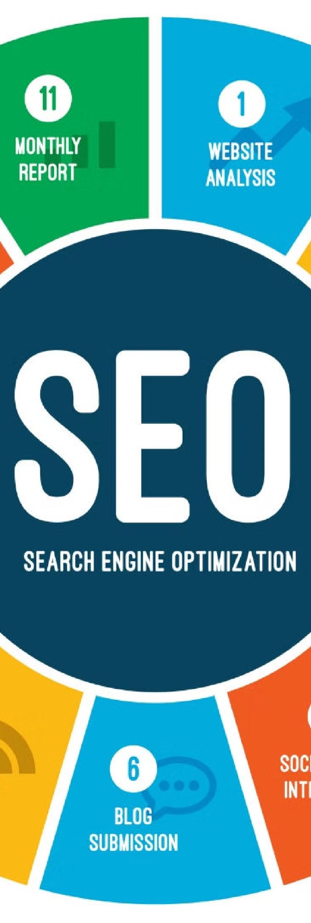

**Optimizing for Search**

**Engine Visibility**

**1**

**Keyword Research**

Conduct thorough keyword research to identify the most relevant and high-

performing search terms related to your skills, expertise, and the types of

services or roles you offer. Strategically incorporate these keywords

throughout your portfolio website to improve its visibility in search engine

results.

**2**

**Metadata Optimization**

Ensure your portfolio website's metadata, including title tags, meta

descriptions, and alt text for images, are optimized to accurately reflect the

content and effectively communicate your unique value proposition to

search engines and users.

**3**

**Content Optimization**

Create engaging and informative content that not only showcases your

work but also aligns with the search intent of your target audience.

Regularly update and refresh your portfolio to maintain its relevance and

keep it ranking highly in search engine results.

**Conclusion and Next Steps**

Key Benefits

Next Steps

Showcase your skills and expertise

-

-

Attract potential employers or clients

-

Establish your personal brand and identity

Improve your online visibility and

-

discoverability

-

Regularly update your portfolio with new

projects

-

Continuously optimize for search engine

visibility

-

Gather and incorporate feedback from your

audience

-

Explore additional features and

functionalities to enhance your portfolio

By developing a comprehensive and well-designed personal portfolio website, you've taken a

significant step in showcasing your talents, connecting with your target audience, and positioning

yourself for success in your professional journey. Remember to regularly maintain and update your

portfolio, continually optimize it for search engines, and seek feedback to ensure it remains a

powerful and effective tool for achieving your goals.